Chapter 4׃ I Can't Believe it!

Tujuh Pembelajaran:

Setelah mempelajari Bab 4, siswa diharapkan mampu:


- Mensyukuri kesempatan dapat mempelajari bahasa Inggris sebagai bahasa pengantar komunikasi International yang diwujudkan dalam semangat belajar.

2.1 Menunjukkan perilaku santun dan peduli dalam melaksanakan komunikasi interpersonal dengan guru dan teman.

2.2 Menunjukkan perilaku jujur, disiplin, percaya diri, dan bertanggung jawab dalam melaksanakan komunikasi transaksional dengan guru dan teman.

2.3 Menunjukkan perilaku tanggung jawab, peduli, kerjasama, dan cinta damai, dalam melaksanakan komunikasi fungsional.

3.2 Menunjukkan perilaku tanggung jawab, peduli, kerjasama, dan cinta damai, dalam melaksanakan komunikasi fungsional.

3.7 Menganalisis fungsi sosial, struktur teks, dan unsur kebahasaan pada pernyataan dan pertanyaan tentang keharusan dan responnya, sesuai dengan konteks penggunaannya.


Bahasa Inggris | 43


4.2 Menyusun teks lisan dan tulis untuk menyatakan dan merespons ungkapan yang mengawali penyampaian berita atau informasi yang mengejutkan dengan memperhatikan fungsi sosial, struktur teks, dan unsur kebahasaan yang benar sesuai konteks.

4.11 Menyusun teks lisan dan tulis untuk menyatakan dan menanyakantentang keharusan, dengan memperhatikan fungsi sosial, struktur teks, dan unsur kebahasaan, yang benar sesuai konteks.

A. WARMER

Think about your past experiences. Share with your friends about these things:

a. The time when you were most surprised.

b. the time when you had to do something and had no other choice.
c. The time when you were expected by someone else to do something.

EXPRESSING SURPRISES

B. OBSERVING AND QUESTIONING

Task 1: Observe the Dialogs.


Read these dialogs. Pay attention to the italicized expressions. Answer the questions that follow.


- Kelas XII SMA/MA/SMK/MAK

Dialog 1

Amida : You know what? My extended family is going to

hold a surprise birthday party for my grandmother

next week.

Diana : Wow! That sounds great. How old is she?

Amida : She’ll be 75 on August 13.

Diana : Really? I didn’t know that she was that age. I

thought that she WAS still around 60. She looks

much younger.

Amida : I think so. Thanks.

Dialog 2

Zahra : Have you heard the latest news about our school?

Raisa : No. What about it?

Zahra : It got Grade A from the National Accreditation Body.

Raisa : Wow! That’s terrific. We should be very proud.

Zahra : We are. It means that our school is of good quality.



- Questions

  - Where do you think each of the conversations takes place?
  - What are the relationships between the speakers?

  - What are the functions of the italicized words?


Bahasa Inggris | 45

Task 3: Read the Dialogs.


Work in pairs. Take turns reading Dialog 1 and Dialog 2.


Language Expressions

Some common expressions of surprises are:

- You know what?

- Guess what?

- Wow! That sounds great.

- Really?

- That’s terrific!

C. COLLECTING INFORMATION

Task 1: Work in pairs.


Work in pairs. Complete the dialogs. Then practice reading them. Pay attention to the pronunciation.

- Kelas XII SMA/MA/SMK/MAK

Dialog 1

Zeni : Have you heard that the due date for the final project is extended?
Riza : ...............................?

Zeni : Yes. It will be due next month.

Riza : .........................! .................. I haven’t even started

yet.

Zeni : Neither have I.

Dialog 2

Roni : .....................? Our favorite singer Maher Zain is

touring again here next month.

Ida : ...............................! That.............................

Roni : We will get a discounted price for the concert tickets in the news agency if we can show our student ID card.
Ida : Let's do it.

Dialog 3

Toni : Mum is planning to buy us each a study desk.

Nina : ...........................? We don’t need to share then.

Thank God.

Toni : Yes. I have wanted a bigger study desk for a long time.

Bahasa Inggris | 47

Task 2: Find Dialogs.


Work in pairs. Find dialogs containing

expressions of surprises. You can go

to the library or search in the Internet.

Task 3: Identify the functions.

Go back to Task 2. Share with the class the expressions of surprises that you have found.

D. ASSOCIATING

Task 1: Use the expressions of surprises.


Work in pairs. List as many as you can expressions that are commonly used to show surprises. You may look at the dialogs above.

Task 2: Create your own.


Work in pairs. Create a dialog that contains

expressions of surprises

- Kelas XII SMA/MA/SMK/MAK

E. COMMUNICATING

Task 1: Use the expressions of surprises.

Think about a situation when you were most surprised. Where did it happen? Who else was involved? What did you say? Create a dialog to represent the situation.

Task 2: Show your understanding.

- Do you know how to express surprises?

- Do you know how to respond to expressions of surprises?

EXPRESSING SURPRISES

A. OBSERVING AND QUESTIONING

Task 1: Observe the dialogs.

Read these dialogs. Pay attention to the italicized expressions.

Dialog 1


Risna : Hello?

Fadil : Hi. This is Fadil.

Risna : Hi, Fadil. You sound terrible. Are you all right?

Fadil : No, I am not. I can’t go to school today.

Risna : Oh, I am sorry to hear that. What’s the problem?

Fadil : My stomach hurts terribly. I think I have a fever as well.

Risna : Oh, no. You have to see the doctor soon.

Fadil : This evening.

Risna : Good. Get well soon, Fadil. Bye.

Fadil : Thanks. Bye.

Bahasa Inggris | 49

Dialog 2


Luki : What’s the matter with you? Are you feeling OK?

Farah : No, not really. I have a toothache.

Luki : Have you seen the dentist?

Farah : Not yet. Many things to do in the office.

Luki : You must talk to the boss. You have to leave early and go to the dentist.
Farah : I’ll do that.

Luki : Hope you’ll feel better. Take care.

Farah : Thanks.


- Dialog 3

Dian : What do we have to prepare for the next trip?

Rian : We are supposed to bring winter clothes. Three pieces at least. We also have to take with us our personal medication.
Dian : Are we supposed to bring some food as well?

Rian : No. It’s provided by the school.


- Dialog 4

Stranger : Excuse me. I need to go to Arjosari. How long will it take from this bus station?
Tania : Around one and a half hours.

Stranger : Do I have to change buses?

Tania : Yes. You have to change at Gadang terminal.

Stranger: Thank you.

Tania : No worries.

- Kelas XII SMA/MA/SMK/MAK

Questions

- Where do you think each of the conversations takes place?

- What are the functions of the italicized words?

Task 2: Listen and repeat.


Listen to your teacher reading the dialogs (Dialogs 1 – 4). Repeat after him/her. Pay attention to the pronunciation.

Task 3: Practice the dialogs.


Work in pairs. Take turns reading the dialogs (Dialogs 1 - 4).

Task 4: Observe the functions.


- have to, must, need, all express necessity. They are used to express the idea that it is necessary for someone to do something.

- (be) supposed to express expectations. It is used to express the idea that someone expects something to happen.

Bahasa Inggris 51

Check whether you understand the functions of the expressions of necessity and expectations. Complete the table like the examples.


Sentences | Functions
You have to see the doctor. | It is necessary for you to see
 | the doctor.
You must talk to the boss.
You must talk to the boss.
You must talk to the boss.
We are supposed to bring | We are expected (by someone) to
winter clothes. | bring winter clothes.
We are supposed to bring | We are expected (by someone) to
some food. | bring some food.
I need to go to Arjosari station.
You have to change at
Gadang station.

Task 5: Identify and write the expressions.

Identify all the italicized words in the dialogs (Dialogs 1- 4), and re-write the sentences containing the words.

You have to see the doctor soon.
_____________________________________________

_____________________________________________

_____________________________________________

_____________________________________________

_____________________________________________

_____________________________________________

_____________________________________________

_____________________________________________

_____________________________________________

- Kelas XII SMA/MA/SMK/MAK

F. COLLECTING INFORMATION

Task 1: Work in pairs.


Work in pairs. Take turns asking

and answering the following questions.

Pay attention to the pronunciation.

- What are some of the things you have to do in the morning?

- What are some of the things you have to do in the evening?

- What do you have to do today?

- What did you have to do yesterday?

- What do you have to do tomorrow?

Task 2: Identify the functions.

Go back to Task 1. Say your sentences in a different way using It is necessary ….

For example:

I have to water the plants in the morning.

It is necessary for me to water the plants in the morning.


Work in pairs. Take turns asking and responding to the questions. Pay attention to the pronunciation.

Bahasa Inggris | 53

- What are some of the things that you are supposed to do as a student?
- What are some of the things that you are supposed to do as a member of a family?
- What are some of the things that you are supposed to do as a member of a society?

Task 4: Identify the functions.

Go back to Task 3. Say your sentences in a different way using as a student, I am expected ….

For example:

As a student, I am supposed to do all the assignments.

As a student, I am expected to do all the assignments.

G. ASSOCIATING

Task 1: Use the expressions of necessity.
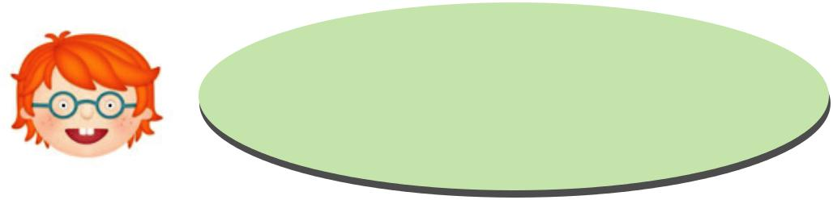

Complete the sentences using your own

words. Share with your friends.

- Students must..............................................................................

- Children have to...........................................................................

- Parents must ...............................................................................

- Drivers have to.............................................................................

- Foreigners must ..........................................................................

- Kelas XII SMA/MA/SMK/MAK

Task 2: Use the expressions of necessity.
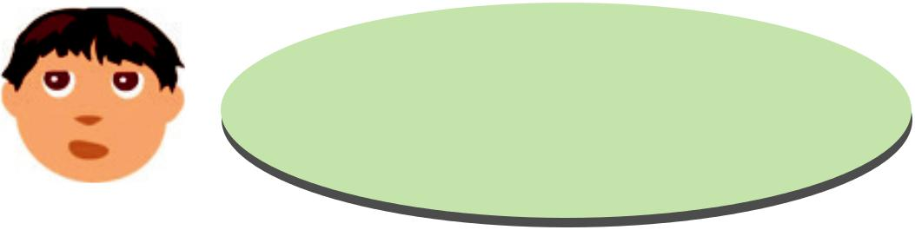

Complete the sentences using your own

words. Share with your friends.

- Students are supposed to...........................................................

- Children are supposed to...........................................................

- Parents are supposed to.............................................................

- Drivers are supposed to..............................................................

- Foreigners are supposed to.......................................................

Task 3: Create your own.


Work in pairs. Create a dialog that contains expressions of necessity or expectations.

H. COMMUNICATING

Task 1: Use the expressions of necessity.

Think about a situation when it was necessary for you to do something. Where did it happen? Who else was involved? What did you say? Create a dialog to represent the situation.

Task 2: Use the expressions of expectations.

Think about a situation when you were expected to do something. Where did it happen? Who else was involved? What did you say? Create a dialog to represent the situation.

Task 3: Write a text that describes a situation when it was necessary for you to do something.

Bahasa Inggris | 55

R E F L E C T I O N


- Do you know how to express necessity?

- Do you know how to respond to expressions of necessity?
- Do you know how to express expectations?
- Do you know how to respond to expressions of expectations?

Source: www.123trf.com


- Kelas XII SMA/MA/SMK/MAK

